
Semester | T.E. Semester VI – Computer Engineering
Subject | Mobile Computing
Subject Professor In-charge | Prof. Sneha Annappanavar
Assisting Teachers | Prof. Sneha Annappanavar
Laboratory | M310A

Student Name | Deep Salunkhe
Roll Number | 21102A0014
TE Division | A

Title:
Orthogonal Codes
Explanation:
In coding theory, orthogonal codes play a crucial role, particularly in communication systems. When two binary codes, A and B, are orthogonal, it means that the inner product of their corresponding sequences is zero.
Mathematically, for binary sequences A=(a1,a2,...,an) and B=(b1,b2,...,bn), the inner product is computed as:
A⋅B=∑i=1nai⋅bi
If A⋅B=0, then the codes A and B are orthogonal.
In our implementation, we utilize a bipolar representation of binary sequences, where '1' is represented as 1 and '0' is represented as -1. This bipolar representation is commonly used in communication systems.
Here's a breakdown of our code implementation:
- Bipolar Function (Bipolar):
  - Converts a binary string to a bipolar sequence.
  - Each '1' is represented as 1, and each '0' is represented as -1.
- Multiply Function (Multiply):
  - Performs element-wise multiplication of two bipolar sequences.
- Main Function:
  - Takes two binary strings as input.
  - Converts them into bipolar sequences.
  - Performs element-wise multiplication of the sequences.
  - Checks if the sum of the multiplied sequence is zero to determine orthogonality.

Implementation:

#include<iostream>
#include<vector>
using namespace std;
void Bipolar(vector<int>&C,string s){
int size=s.length();
for(int i=0;i<size;i++){
if(s[i]=='1'){
C.push_back(1);
}else{
C.push_back(-1);
}
}
}

void Multiply(vector<int>A,vector<int>B,vector<int>&M){
int size=A.size();
for(int i=0;i<size;i++){
M.push_back(A[i]*B[i]);
}
}

void TakeCode(string &s,int size){

int originalsize=size;

cin>>s;
if(s.length()!=size){
cout<<"Invalid size "<<endl;
return;
}
for(int i=0;i<size;i++){
if(s[i]=='1'|| s[i]=='0'){
continue;
}else{
cout<<"Not a Binary"<<endl;
return;
}

}

}

int main(){
int len=0;
cout<<"Enter length"<<endl;
cin>>len;
string A,B;
cout<<"Enter first code(Binary)"<<endl;
TakeCode(A,len);
cout<<"Enter Secont code(Binary)"<<endl;
TakeCode(B,len);
vector<int>AC,BC,M;
Bipolar(AC,A);
Bipolar(BC,B);
Multiply(AC,BC,M);
int temp=0;
int size=A.size();
for(int i=0;i<size;i++){
temp=temp+M[i];
}

for(int i=0;i<len;i++){
cout<<M[i];
if(i!=len-1) cout<<"*";
}
cout<<"="<<temp<<endl;

if(temp==0){
cout<<"It is Orthogonal"<<endl;

}else
{
cout<<"It is Not Orthogonal"<<endl;
}
return 0;
}

End Result:

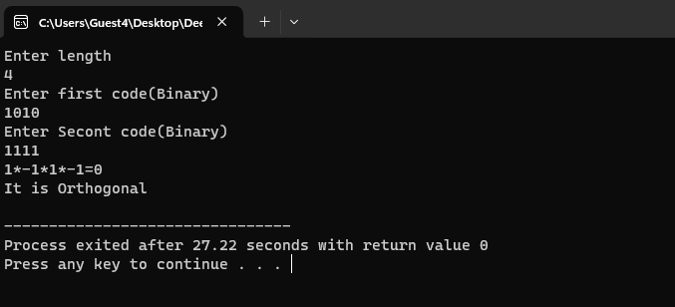
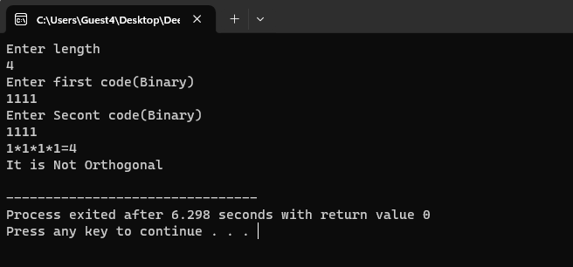

Conclusion:

The code essentially checks whether the two input binary codes are orthogonal by converting them to bipolar sequences and performing element-wise multiplication. If the sum of the multiplied sequence is zero, the codes are orthogonal.

